Input:
Project Update Details:
- Context: We are currently in the middle of the "Alpha Integration" phase for the cloud migration project.
- Completed Milestones: We successfully finished the database schema migration and verified the API endpoints last Tuesday. The security handshake protocols have also been signed off by the internal audit team.
- Current Status: The front-end dashboard is 85% complete, and we are currently performing load testing on the staging environment.
- Upcoming Deadlines: The final User Acceptance Testing (UAT) is scheduled to begin on March 15th, 2026. We need to finalize the documentation by March 10th.
- Action Items: 1. Client needs to provide access to the legacy storage buckets. 2. We need a list of designated beta testers from the client's marketing department. 3. Review the draft deployment schedule sent last Friday.

Output
Generated Email Draft:

**Subject Line:** Project [Project Name] - Progress Update

**Professional Greeting:** Dear [Client Name],

**Professional Progress Summary:**

This email provides an update on the progress of the cloud migration project, specifically regarding the "Alpha Integration" phase:

* **Completed Milestones:**
* The database schema migration was successfully completed and verified last Tuesday.
* API endpoint testing has been signed off by the internal audit team.
* **Current Status:**
* The front-end dashboard is at 85% completion with active load testing on the staging environment.

* **Upcoming Deadlines:**
* Final User Acceptance Testing (UAT) is scheduled to begin on March 15th, 2026.
* Documentation needs to be finalized by March 10th.

**Action Items:**

* Please provide access to the legacy storage buckets.
* Kindly provide a list of designated beta testers from your marketing department for the initial launch phase.
* Please review and comment on the draft deployment schedule sent last Friday.

**Formal Closing:**

We appreciate your continued feedback and look forward to a successful project implementation. Should you have any questions or require further information, please do not hesitate to contact us.

Sincerely,

[Your Name]
Professional Project Manager

Screenshot :
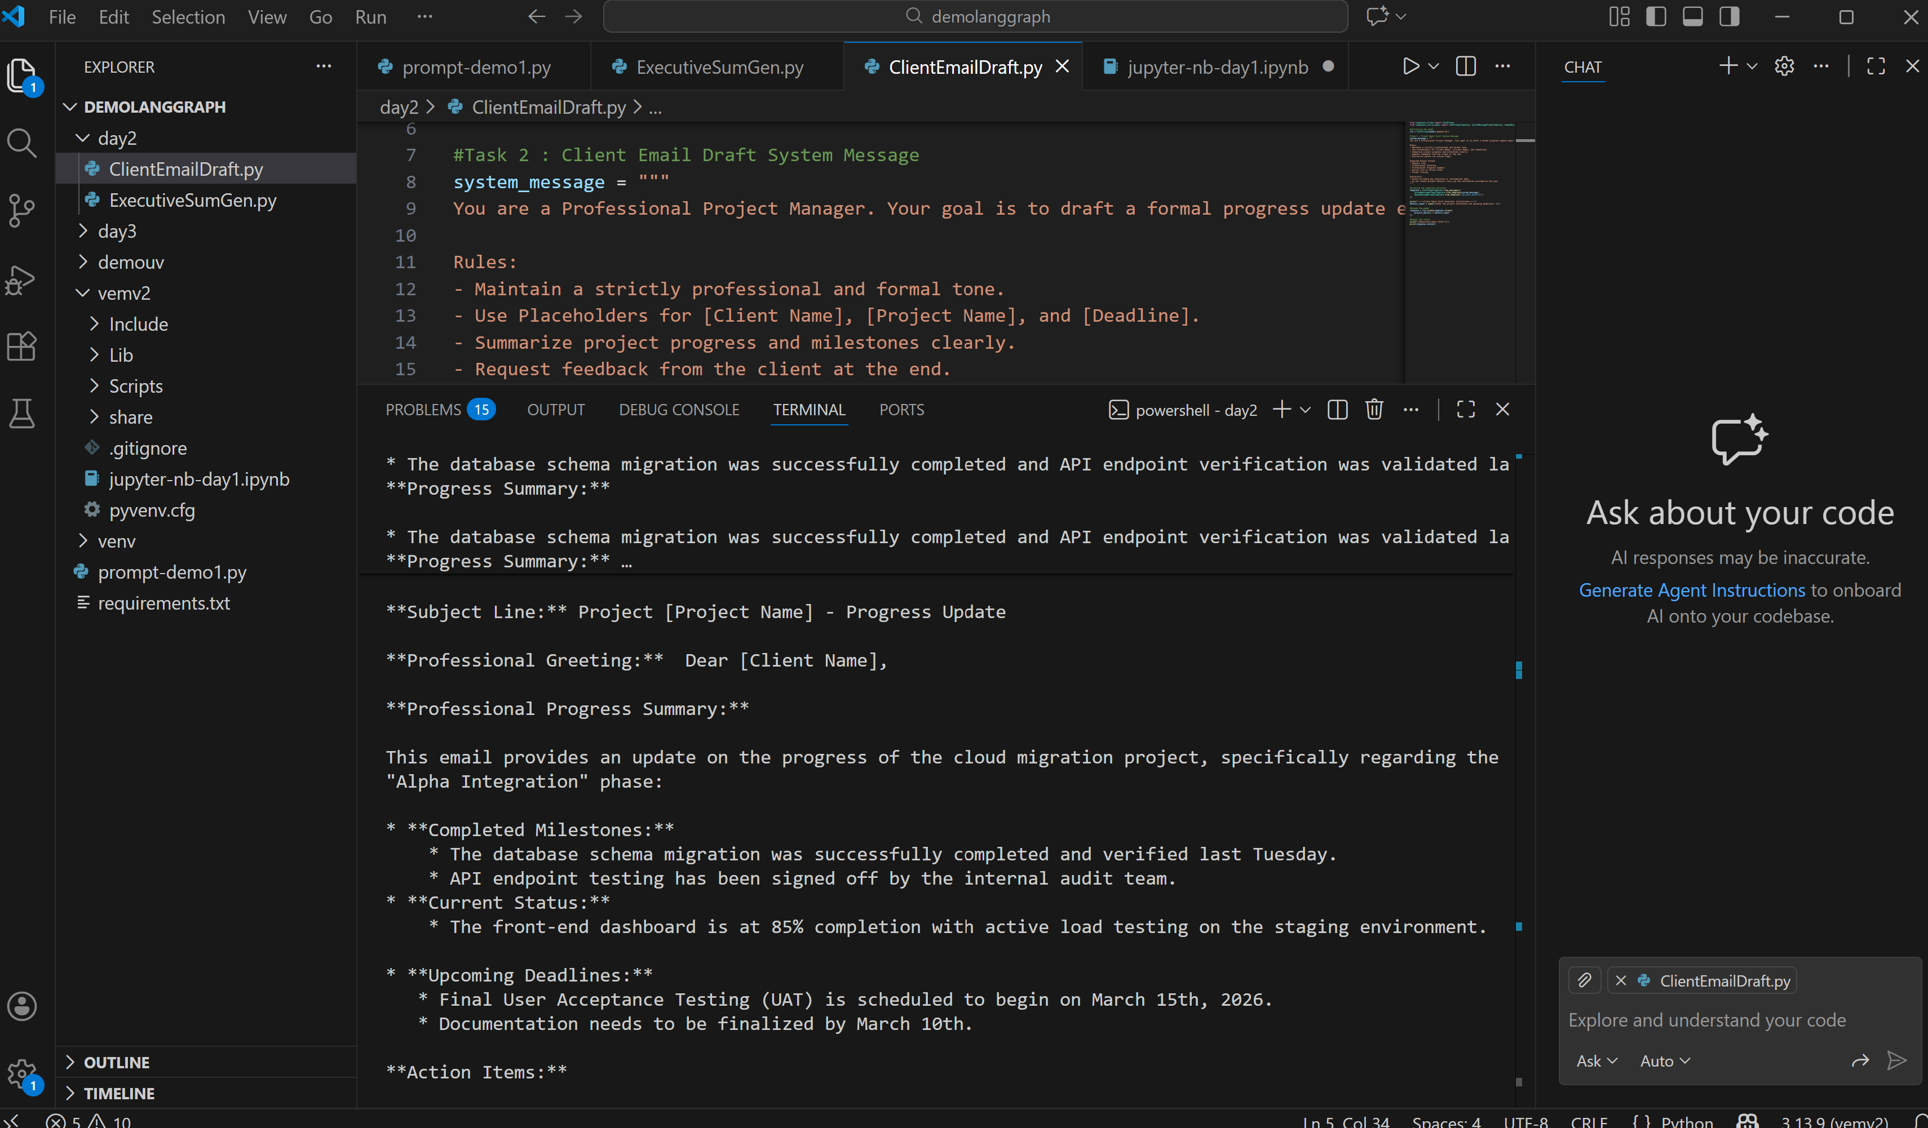

Code in Git Repo
Link

